2023-2024 EMERGING PLAYWRIGHTS COMPETITION
APPLICATION
Student information:
NAME:___________________________________________ SCHOOL:_____________________
GRADE:__________________ AGE _________________
EMAIL ADDRESS:________________________________________________________________
HOME ADDRESS ________________________________________________________________
PHONE NUMBER:________________________________________________________________
TITLE OF PLAY:___________________________________________________________________
Sponsoring Teacher Information:
Name:__________________________________________________________________________
School Address:___________________________________________________________________
City:___________________________State:__________________Zip:___________
Email Address:____________________________________________________________________
Phone Number:______________________________________________________
*******************************************************************************************************************
[ ] By signing I agree that all rights to submitted script belong to the student and if the student receives a prize, Riverwalk Theatre may produce one (1) public performance. (Student Please Initial)
STUDENT SIGNATURE:____________________________________________________________
PARENT/GUARDIAN SIGNATURE:___________________________________________________
SPONSORING TEACHER SIGNATURE:_______________________________________________
DEADLINE FOR ENTRIES 5pm 02/07/2024
(Generously Supported by Gordon Masters.)
Office Use Only
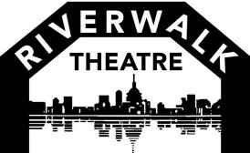
Date Received: _______________________ Number: _____________________________

